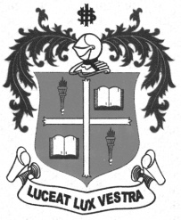
LOYOLA COLLEGE (AUTONOMOUS), CHENNAI – 600 034
M.A. DEGREE EXAMINATION - TAMIL LITERATURE
THIRD SEMESTER – NOVEMBER 2012

TL 3802 - ETHICAL LITERATURE

Date : 06/11/2012 Dept. No. Max. : 100 Marks

Time : 9:00 - 12:00


x=
- 
- 

- 
- 
- 
- 


 x=
- 
- 
- 
- 
- 
- 



 x=
- 

- 
- 
- 

